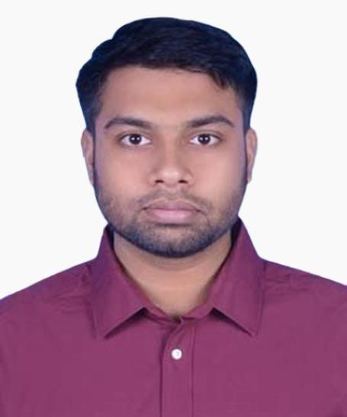

**Md. Amir Hamza**

12th Oct 1996, Bangladesh

Contact

**Address:**

Mohipal, Feni

**Mobile:**

(+880)1830422980

**Email:**

[ah.zahed00@gmail.com](mailto:ah.zahed00@gmail.com)

Languages

Bangla English

**Git Profile:**

<https://github.com/ahzahed>

# Career Objective

Looking for a challenging role in a reputed organization where I will be able to utilize my critical thinking. Through my learning agility, adaptability and teamwork I can drive innovative solutions.

# Technical Skill Highlights

|  |  |
| --- | --- |
| **Intermediate**   * HTML5, CSS3, SASS, Tailwind, JavaScript (ES6), PHP7   **Basic Knowledge**   * C/C++, Java * WordPress * MySQL, Express, Node, Firebase * Camtasia Studio,   Adobe Premiere Pro, After Effect | * Bootstrap 4, React, Next.js, Vue, Laravel * GitHub * Data Structure & Algorithm * Windows, Linux, Mac * Blender, Photoshop * MS Word, PowerPoint, MS Excel |

|  |  |  |  |
| --- | --- | --- | --- |
| **Education** |  |  |  |
| **CSE in (B.Sc.)** | Eastern University | Year: 2019 | 3.51 |
| **HSC** | Govt. Science College | Year: 2015 | 4.17 |
| **SSC** | Tamirul Millat Kamil | Year: 2013 | 5.00 |
| **Career** |  |  |  |

## Arbree Solutions

* 06/22 – Current | Frontend Developer (Reactjs, vuejs)

### Projects that I am working on under this company:

* + Daahuk ([Figma Design](https://www.figma.com/file/WITtSCWd5DIJeONYjF5aCs/Daahuk-Redesign?node-id=0%3A1&t=BRMJQgSFxYxdHNle-0))- Frontend using Tailwind, Nuxt
  + <https://dev.gprojukti.com/> - Frontend using Next, Sass
  + Maintaining and bug fixing on ‘University of Asia Pacific’ – <https://uapfrontend.vercel.app/>

## Alpha Square Partners

* 04/21 – 05/22 | Frontend Developer (Reactjs)

### Projects that I’ve worked on under this company:

* + <https://owlet.vercel.app/>- Frontend using Bootstrap 4, Nextjs, REST API
  + Working on ‘University of Asia Pacific’ project using Nuxtjs, Bootstrap, SASS. Version Control – Bitbucket <https://uapfrontend.vercel.app/>

## SheBa Web Technology

- 04/20 – 10/20 | IT Executive

### Projects that I’ve worked on under this company:

* + <https://demo.zibonshathi.com/>- Full Development using Bootstrap 4, Laravel 7
  + <https://tessomotechnologies.com/>- Front-end
  + <https://diisoafrica.com/>- Front-end
  + <https://crm.shebawebtech.com/>- (Multi-Authentication and User Chat System and more using Laravel 7)

# Personal Project

## Alg Ltd

* + Developed with React, Firebase, Bootstrap, SASS
  + [https://alglimited.com](https://alglimited.com/)

## Arshipper

* + Developed with React, Firebase, Bootstrap
  + <https://arshipper.vercel.app/> - Under Construction

# Skill Development & Online Course

* Creative It – professional Web Dev. (PHP7, Laravel 7)
* It Bari – Web Design, Wordpress
* JavaScript – Stack Learner, Udemy (John Smilga, Net Ninja)
* ReactJS – Stack Learner, Udemy (John Smilga)
* Redux – Learn With Sumit
* Next.js – Udemy (Maximilan)
* Vue JS 3 – Udemy (Net Ninja)
* Udemy – Bootstrap 4, PSD to HTML

# Reference

**Mahadi Tahsan**

* Faculty & Web Developer at Creative It Institute.

- Mobile: 01990779785

* Email: [tahsan.cit.bd@gmail.com](mailto:tahsan.cit.bd@gmail.com)

**Haysam Mahmud**

* Admin, Account Manager
* Arbree Limited

- Mobile: 01723817812

* Email: haysam.arbree@gmail.com